

A201

STIJ 3074

PROJECT WEB APPLICATION DEVELOPMENT

TITLE: HOTEL MANAGEMENT SYSTEM

LECTURER: SIR AHMAD HANIS BIN MOHD SHABLI

NAME: MUHAMAD IRWAN IHFAN BIN KHALID

MATRIC: 263095

LINK GITHUB: https://github.com/muhamadirwan98/stij3074-.git

LINK APP: http://irwanihfan.infinityfreeapp.com/Hotel/index.html

**PHP and HTML code**



**SCREENSHOT OF WEB LAYOUT**

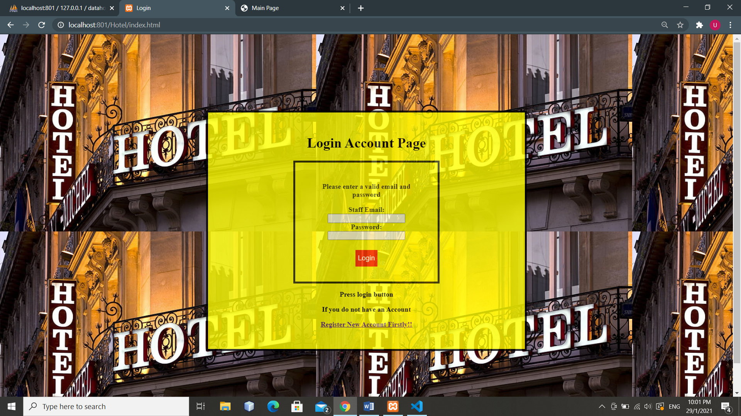

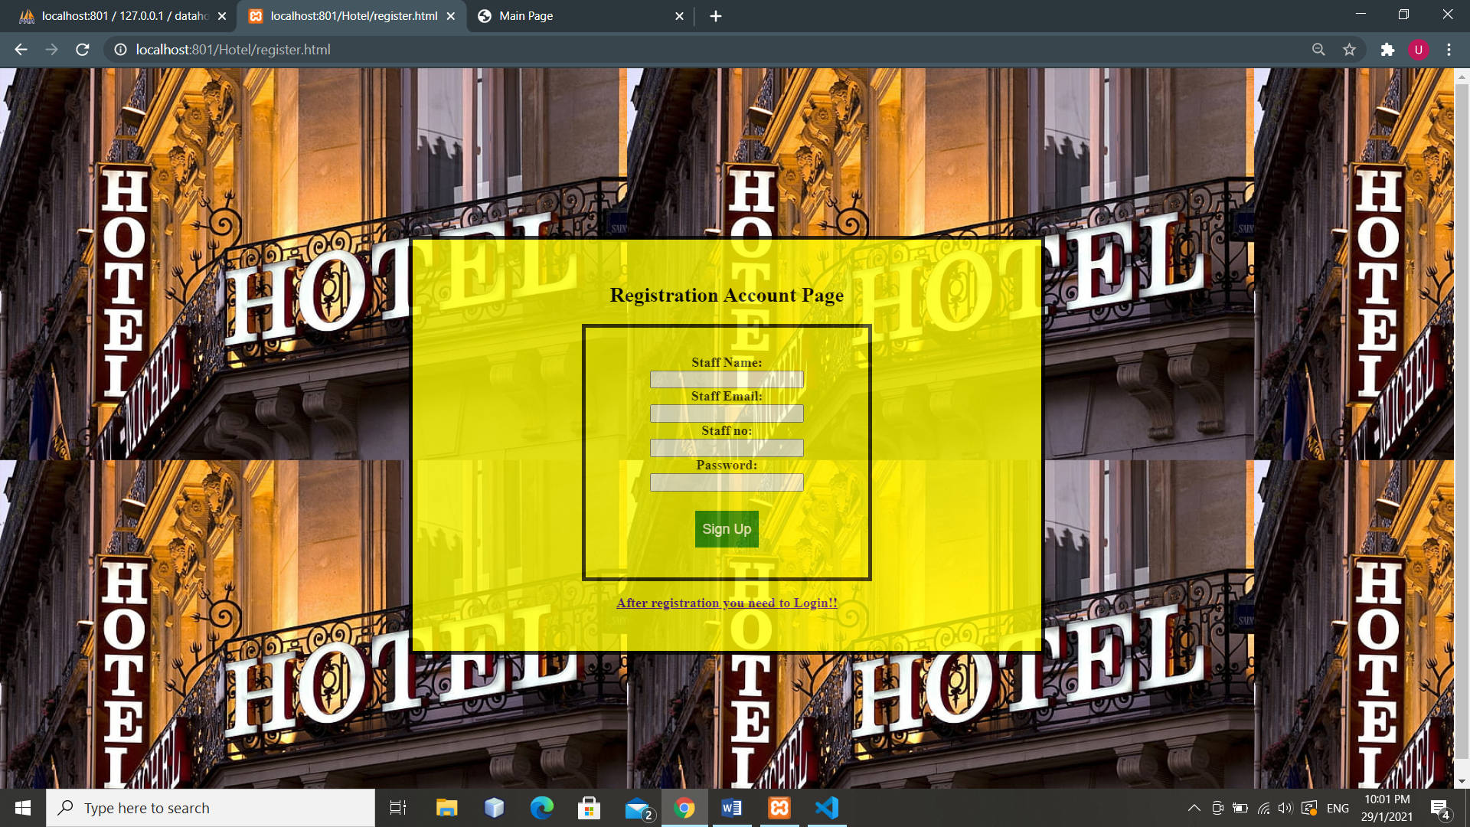

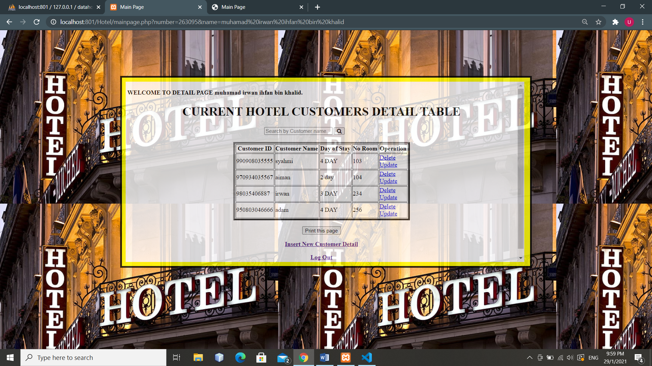

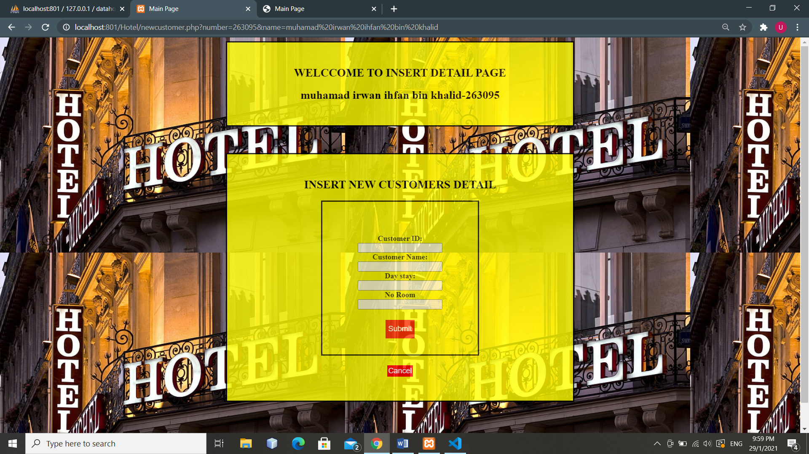

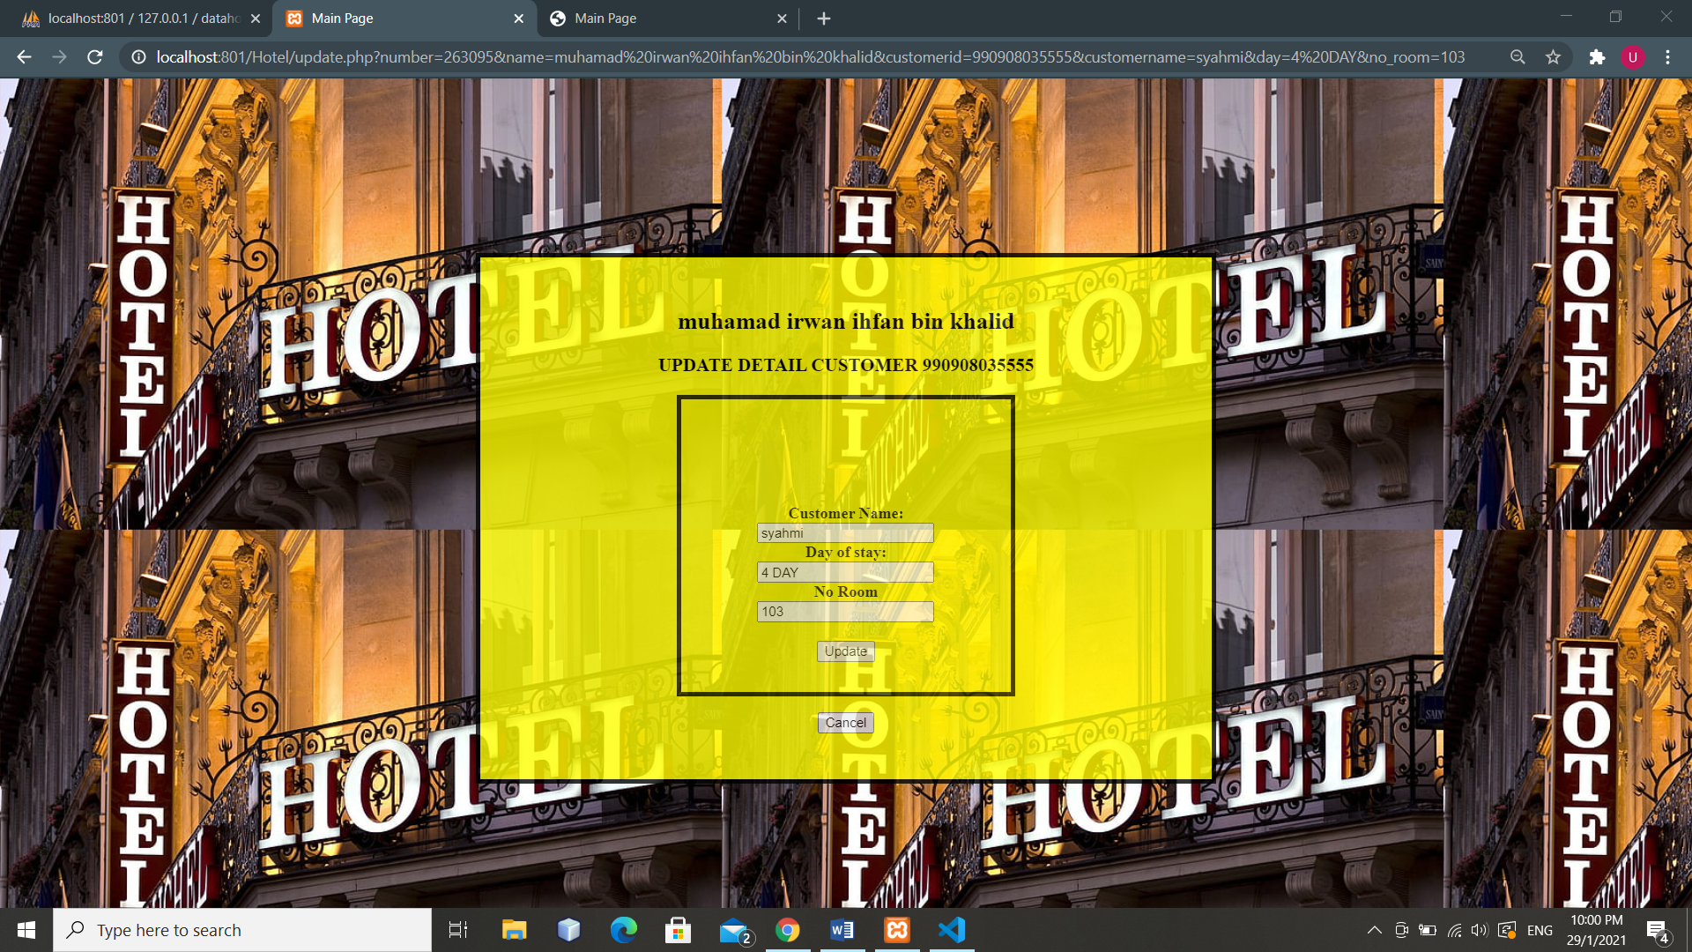

**DATABASE SNAPSHOT**

